**THE PROTOCOL OF THE SESSION OF THE AWARDING COMMITTEE OF THE 15th INTERNATIONAL CRIMEAN CONFERENCE “COSMOS AND BIOSPHERE”**

1. The Program and Organizing Committee on 15th International Crimean conference “Cosmos and Biosphere” accepted decision to form a Work Award Committee (WAC) for Benveniste Association Awarding of the best reporter. The members of the Program Committee are:

1. E.N. Chuyan (Russia);

2. Vincenzo Valenzi (Italy);

3. Parchina S.S. (Russia)

**2. After discussion the members of WAC accepted the next criteria for awarding:**

1. the scientific report should be devoted to the study of the influence of physical factors on the biological system;

2. the scientific report should be devoted to the ecological problems of the biosphere and near-Earth outer space;

3. оne of the main ideas of the report should be the role of water as a «sensor» of low-intensity physical and chemical factors and/or in the effects of space weather;

4. the results of the work will explain the possible mechanisms of the influence of physical or chemical factors on the biological system, space weather on biological systems and physico-chemical processes;

5. scientific works should be experimental in nature and be promising for future research.

**3. After discussing the reports, that were presented at the conference, a decision was made and the winners of the competition for the best reports were announced:**

**1 prize**

1. ***Widom  Allan*** The enigma of increase of coherence in water with very low signals in the ayush and m0dern medicine.

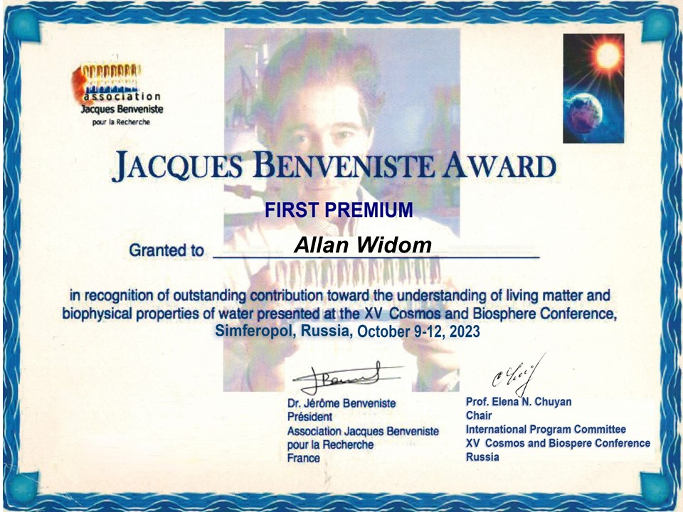

[Convegno Lern Cirps Sapienza Roma Allan Widom fisico teorico di Boston 1](https://www.youtube.com/watch?v=1BfLeD01pbw)

1. Pak G.D., Salikhov N.M., Biotropic effect of variations in the flux of gamma quanta from the natural background radiation on the human body

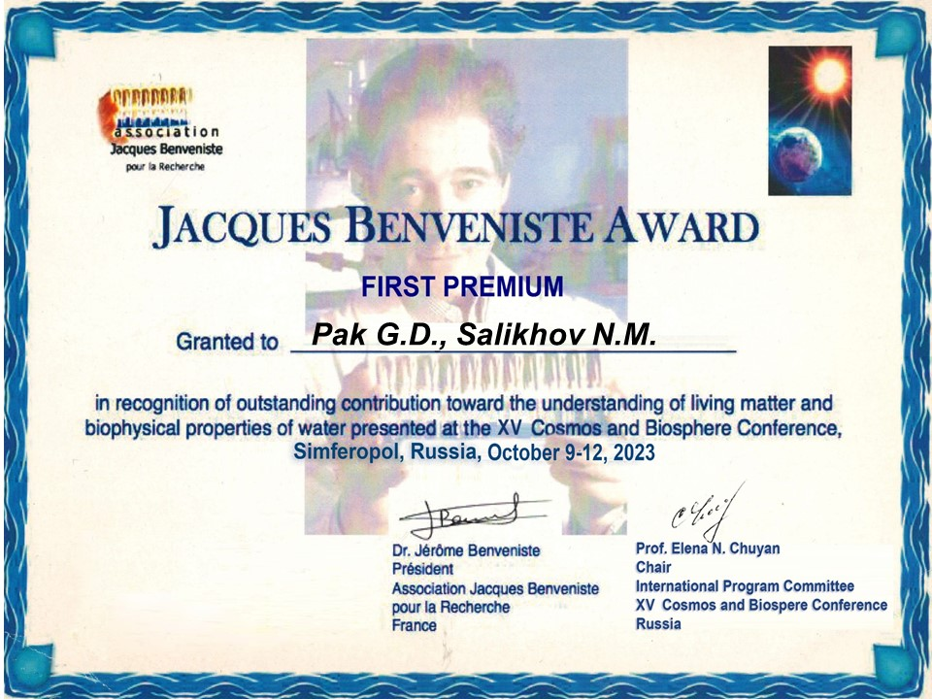

[**Эпизод 3.23**](https://youtu.be/Wk3eY1szHlI)

1. Ravaeva M.Yu. Physiological aspects of anti-ischemic activity of low-intensity electromagnetic radiation of extremely high frequency

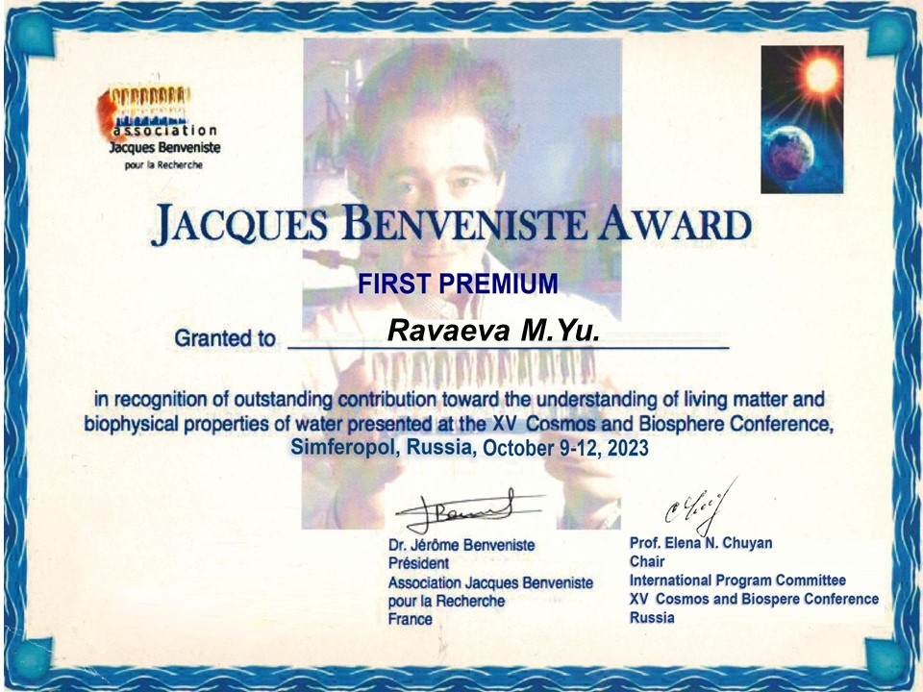

[**Эпизод 0.15**](https://youtu.be/Wk3eY1szHlI)

**2 prize**

1. Khusainov D.R. Changes in the analgesic activity of aspirin and ibuprofen under conditions of magnetic shielding.

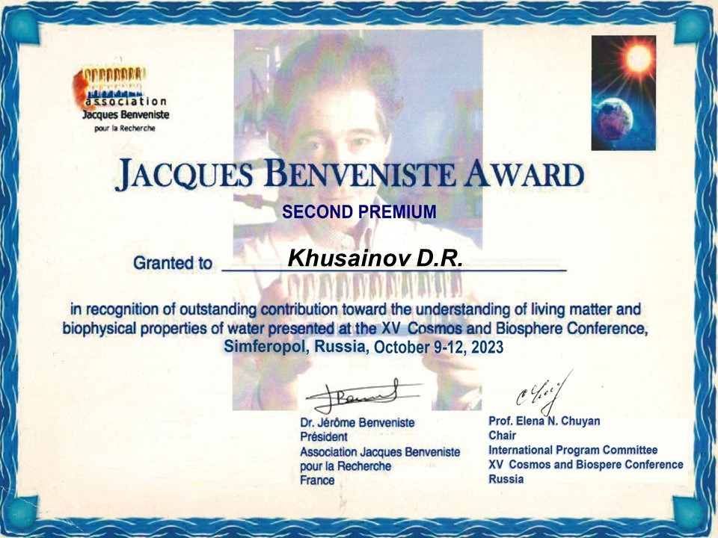

[**Эпизод 0.44**](https://youtu.be/Wk3eY1szHlI)

1. Novikov V.V. The role of water in the effect of weak combined magnetic fields on the respiratory burst of neutrophils.

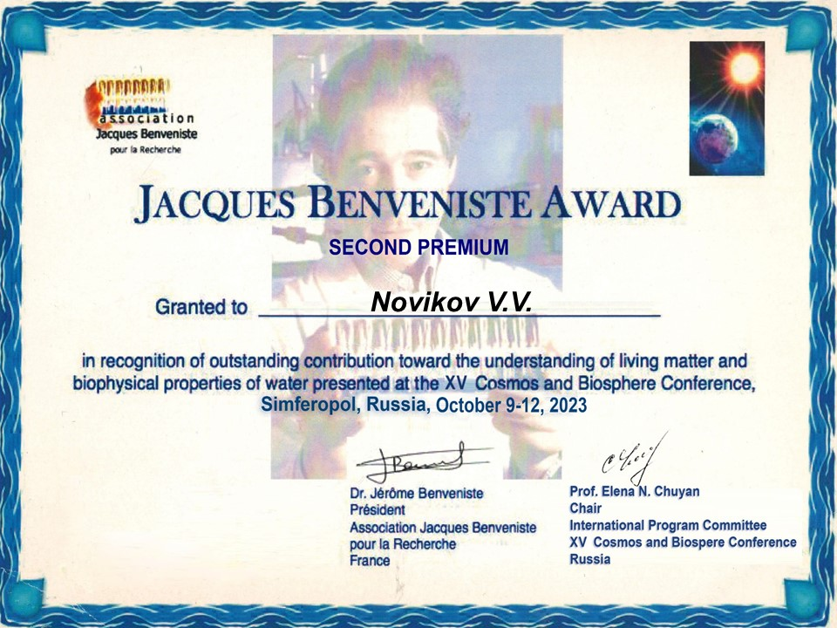

[**Эпизод 3.39**](https://youtu.be/yluHSuhs44k)

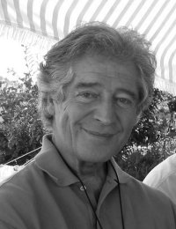

**Association Jacques Benveniste pour la Recherche**

web: [http://www.jacques-benveniste.org](http://www.jacques-benveniste.org/)

«Thank you for the «SPACE AND BIOSPHERE» JACQUES-BENVENISTE AWARD Nominees. Thank you very much for again organising the JACQUES-BENVENISTE AWARD and the expression of my gratitude goes to all the JACQUES-BENVENISTE AWARD SELECTION COMMITTEE MEMBERS. I hope to be able to be with you in two years for the XVI SPACE&BIOSPHERE Conference.Meanwhile i send you my kind regards»

**Dr Jérôme Benveniste, PhD**

**Président, Association Jacques Benveniste pour la Recherche**